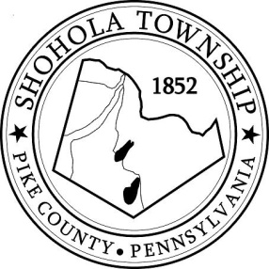
SHOHOLA TOWNSHIP BOARD OF SUPERVISORS
159 Twin Lakes Road
MUNICIPAL BUILDING, SHOHOLA, PA, 18458

AGENDA
August 10, 2023

ATTENDANCE

MEETING CALLED TO ORDER - PLEDGE ALLEGIANCE TO THE FLAG

APPROVAL OF MINUTES: Motion to approve Minutes of the Regular Meeting of the Board on July 13, 2023.

APPROVAL OF EXPENDITURES: Motion to approve expenditures for July 2023

APPROVAL OF TREASURERS REPORT: Motion to approve Treasurers’ Report for July 2023.

PLANNING COMMISSION:
- Fleming Conditional Use

SOLICITORS REPORT:

ANNOUNCEMENTS
- None

OLD BUSINESS:
- Fire Ordinance
- Dirt & Gravel Project

NEW BUSINESS:
- Road Master Salary

CORRESPONDENCE:
- Email from Jenni Hamil

REPORTS TO TH E BOARD
- Building Permits 8 residential building permits in July 2023
- Zoning and Sewage 8 Zoning; 9 Sewage and 4 Well Permits in July 2023
- Road Department
- Park Committee
- Fire Department
- Ambulance

SUPERVISORS COMMENTS:

PUBLIC COMMENTS:

